Electric Utility Major Storm Restoration Network: Participants, Assets, Transactions, Contracts, and InefficienciesJoe Koressel
Target Audience: Kentucky Utility Companies
Technology Stack: Python, Open-Meteo API, Pandas, Requests, PostgreSQL, Dash, Plotly
Background
This assignment examines the electric utility major storm restoration network, focusing on how utilities coordinate restoration work, mutual aid crews, emergency communications, lodging logistics, and financial settlement after a major outage event. The network includes many independent participants and shared assets, and it is governed by mutual aid agreements, vendor contracts, emergency procedures, accounting controls, and regulatory reporting rules. Current inefficiencies include fragmented data systems, delayed situational awareness, manual logistics coordination, invoice reconciliation delays, reimbursement disputes, and audit burden.
Business Problem
Weather conditions can significantly impact utility operations and planning, Kentucky electric utility companies require reliable cost-effective weather intelligence to support infrastructure monitoring, resource planning, and operational awareness.
Objectives
- Develop an interactive weather intelligence application/platform for Kentucky electric utility companies
- Integrate weather forecast data from the Open-Meteo API across Kentucky locations
- Generate utility-relevant environmental indicators and seasonal metrics such as Heating Degree Days (HDD) and Cooling Degree Days (CDD)
- Delivery location-specific weather insights to support operational planning and infrastructure awareness.
- Enable weather-informed decision support through interactive data visualization and monitoring capabilities.

Technical Approach
- Utility Weather Monitoring
  - Location-based weather display for selected Kentucky regions
  - Forecasted temperature, precipitation, wind speed, wind gusts and weather codes
  - Visual weather timeline showing operationally relevant weather trends
- Utility Risk and Demand Indicators
  - Derived metrics based on weather parameters
  - Heating Degree Days (HDD) and Cooling Degree Days (CDD) calculations
  - Wind and precipitation threshold categories to identify elevated operational conditions
- Interactive User Interface
  - Interactive Plotly visualizations for weather and utility metrics
  - Location selection for Kentucky cities or regions
  - Filtering by forecast window, weather variable, and risk category

Technical Architecture + Diagram
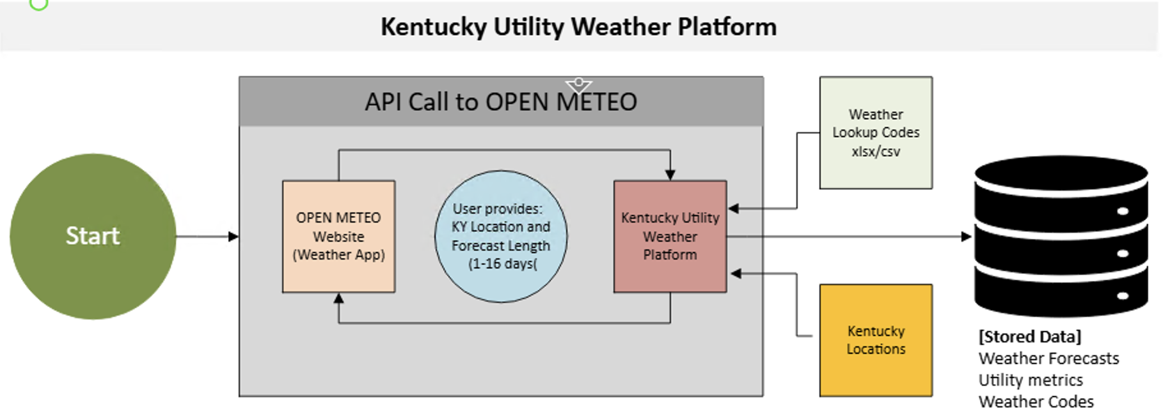

Backend Components
- Data Retrieval: Open-Meteo API integration for Kentucky weather forecast data
- Location Lookup: Kentucky location reference data with city/region, latitude, and longitude
- Data Processing: Python and Pandas for cleaning, formatting, and structuring weather data
- Utility Metrics Engine: Calculates Heating Degree Days (HDD), Cooling Degree Days (CDD), wind risk categories, and weather indicators
- Weather Code Lookup: Converts Open-Meteo weather codes into readable weather descriptions
- Data Storage: Stores weather forecasts, utility metrics, weather codes, and location data

Frontend Components
- Web Framework: Dash for building the interactive web-based platform
- Visualization: Plotly for weather trends, HDD/CDD metrics, and risk indicators
- User Inputs: Location selection and forecast window selection
- Display Outputs: Weather conditions, demand indicators, wind risk categories, and utility-focused summaries

Data Flow
- User selects a Kentucky location and forecast window
- Application sends an API request to Open-Meteo
- Open-Meteo returns weather forecast data
- Python processes and structures the returned weather data
- Weather codes and location reference data are joined as needed
- Utility metrics are calculated, including HDD, CDD, and wind risk categories
- Processed results are stored for reuse and analysis
- Dash/Plotly displays weather and demand insights to the user

Data Quality and Validation Plan

The pipeline will include validation checks to ensure that weather data is complete, accurate, and usable before it is transformed and displayed in the dashboard. API responses will be checked for successful HTTP status codes before processing. Required fields such as temperature, precipitation, wind speed, wind gusts, weather code, location, and forecast date will be validated for presence and expected data types.

The pipeline will also check for duplicate forecast records, missing forecast periods, invalid date ranges, and out-of-range weather values. Transformation validation will compare row counts before and after processing and verify that derived utility metrics, including Heating Degree Days (HDD), Cooling Degree Days (CDD), and weather risk categories, are calculated correctly. Any validation failures will be logged for troubleshooting and pipeline monitoring.

Data Sources and APIs
Primary Data Source: Open-Meteo API
- Endpoint: https://api.open-meteo.com/v1/forecast
- Location Scope: Kentucky locations using latitude and longitude
- Forecast Window: 1–16 days
- Data Parameters:
  - temperature
  - wind speed
  - wind gusts
  - precipitation
  - weather code
- Units: Fahrenheit, mph, inches
- Timezone: America/New_York (Eastern Standard Time)

Reference Data Sources
- Kentucky Locations CSV/XLSX: city or region names with latitude and longitude
- Weather Code Lookup CSV/XLSX: Open-Meteo weather code descriptions
- Threshold Definitions CSV/XLSX: utility risk categories for wind, precipitation, temperature, HDD, and CDD

Weather Code Reference
- CSV/XLSX-based lookup table mapping Open-Meteo numeric weather codes to readable descriptions
- Supports human-readable weather condition display
- Enables translation of API weather values into utility-focused terminology
- Supports weather condition categorization for operational awareness

Utility Demand Indicator Logic
  - Weather Parameter Analysis
    - Temperature
    - < 32°F: Increased heating demand potential
    - 32–50°F: Moderate heating demand conditions
    - 50–70°F: Mild demand conditions
    - 70–85°F: Increased cooling demand potential
    - 85°F: Elevated cooling demand conditions
    - Precipitation
- 0%: Normal operating conditions
- 0–30%: Minor operational awareness conditions
- 30–70%: Elevated weather monitoring conditions
- 70%: Increased weather-related operational awareness
    - Wind Speed
- <10 mph: Normal operating conditions
- 10–20 mph: Elevated monitoring conditions
- 20 mph: Increased operational awareness conditions

Demand Indicators
- Heating Degree Days (HDD) calculation and monitoring
- Cooling Degree Days (CDD) calculation and monitoring
- Weather threshold classifications for operational awareness

Responsive Design Considerations
- Desktop: Multi-panel layout displaying weather trends and utility metrics
- Tablet: Simplified chart layout with responsive filtering
- Mobile: Compact forecast summaries and utility indicators

Implementation Plan
- Phase 1: Foundation & Data Acquisition (Week 1)
- Finalize project proposal and architecture diagram
- Evaluate Open-Meteo source data and API capabilities
- Create project structure and establish data requirements

- Phase 2: Data Integration & Storage (Week 2)
- Implement Open-Meteo API connection
- Create Kentucky location reference files
- Design PostgreSQL schema and storage structure

- Phase 3: ETL Development & Metrics (Week 3)
- Develop data ingestion workflow
- Implement weather transformations and utility metrics
- Calculate HDD/CDD indicators
- Create weather code lookup integration

- Phase 4: Visualization & Interface Development (Week 4)
- Develop Dash interface
- Create Plotly visualizations
- Add location selection and filtering capabilities

- Phase 5: Testing & Finalization (Week 5)
- Validate API responses and transformed outputs
- Test application functionality and performance
- Finalize documentation and presentation materials

Success Metrics
- Technical Metrics
- API Reliability: >99% successful API requests
- Data Validation: Successful weather field and transformation checks
- Application Response Time: <10 seconds initial load time

- User Experience Metrics
- Interactive location selection and forecast filtering operational
- HDD/CDD calculations generated successfully
- Utility metrics displayed through visual outputs

- Business Impact Metrics
- Demonstrates weather-informed operational awareness
- Provides utility-focused weather indicators and demand insights
- Shows practical application of data engineering and analytics concepts

Risk Assessment and Mitigation
- Technical Risks
- API Availability: Implement error handling and retry logic
- Data Quality: Validate weather values and forecast ranges
- Performance Constraints: Store processed results to minimize repeat API calls

- Project Risks
- Scope Creep: Maintain focus on core weather and utility metrics
- Timeline Delays: Follow phased weekly milestones
- Feature Expansion: Reserve enhancements for future iterations

Budget and Resources

Development Resources
- Libraries: Python, Dash, Plotly, Pandas, Requests, PostgreSQL
- Data Source: Open-Meteo API (free, no API key required)
- Development Environment: VS Code and GitHub

Time Investment
- Development: 5-week implementation schedule
- Testing: Integrated throughout development
- Documentation: Updated throughout project lifecycle

Conclusion
The Kentucky Utility Weather & Demand Analytics Pipeline provides a practical approach for integrating weather forecast information with utility-focused demand indicators and operational metrics. By leveraging publicly available weather data and open-source technologies, the project demonstrates a cost-effective solution that supports environmental awareness and utility planning objectives.

Next Steps
- Stakeholder review and proposal approval
- Verify Open-Meteo API data availability and parameters
- Develop MVP with weather retrieval and HDD/CDD calculations
- Begin ETL implementation and database design
- Start interface development and visualization planning

